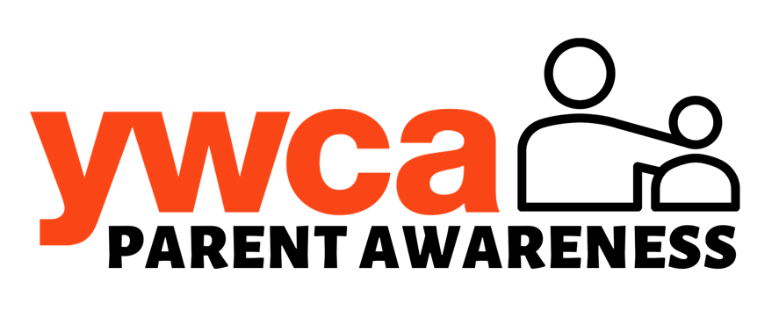
Creating A Bully-Free Culture:
Modeling Kindness & Inclusivity for Our Children
January 26, 2023

Presenter: Melissa Schulz, Trainer & Executive Coach, GrayWolf Consulting LLC

KEY TAKEAWAYS

Recognizing Bullying Behavior
- Bullying can be Physical, Verbal, Relational, or Cyber, and involves a power differential (actual or perceived).
- Conflict is not bullying in and of itself, but we need to learn to resolve conflict in a healthy way.
- Both the target of bullying and the child exhibiting bullying behaviors are struggling. And it impacts children who witness it as well.
- Adults can influence the culture of a community, discourage bullying behavior, and support targets.
- “Culture is as much about what we encourage as it is about what we permit.”
What Can Adults Do To Teach and Influence?
- Know how to identify bullying and harassment and interrupt it ALWAYS – in your home, with friends, in the classroom, on the playground, on the playing fields.
- Talk about unkind, inappropriate, and bullying behavior and how to stand up to it safely (we can all be UPSTANDERS!); role play how you’ll respond in “tense” situations.
- Remember to focus on the behaviors, not the person. Don’t pigeonhole a child who is behaving badly as a “bad kid” or they may continue to play that part.
- Recognize your own unkind behaviors and comments towards others and yourself. Remember your children are ALWAYS watching and listening even when they are in their room, in the backseat, or playing with friends across the park. Avoid gossip and putdowns.
- Teach young people skills for effective conflict resolution and role model it in your own life.
- Build your emotional intelligence and help build it in others. Cultivate gratitude, empathy, and kindness one person at a time (starting with yourself).
- Listen to your children with compassion, validate their feelings, and help them advocate for themselves.
- Get to know people different from you, educate yourself, lean into your own unconscious bias. Expose your children to other cultures and other interests.
- Show humility; admit mistakes, share your failures so children know they don’t have to be perfect.

