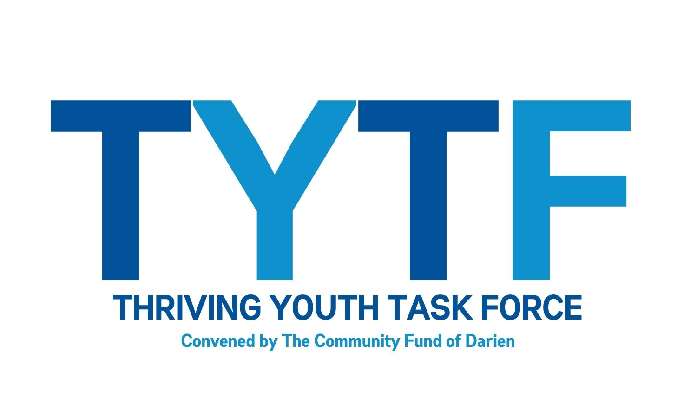
Underage Drinking Prevention

How to tell if your child is drinking alcohol¹

Warning Signs
Although the following signs may indicate a problem with alcohol or other drugs, some also reflect normal growing pains. Experts believe that a drinking problem is more likely if you notice several of these signs at the same time, if they occur suddenly, or if some of them are extreme in nature.
- Mood changes: flare-ups of temper, irritability, and defensiveness
- School problems: poor attendance, low grades, and/or recent disciplinary action
- Rebellion against family rules
- Friend changes: switching friends and a reluctance to let you get to know the new friends
- A “nothing matters” attitude: sloppy appearance, a lack of involvement in former interests, and general low energy
- Alcohol presence: finding it in your child’s room or backpack or smelling alcohol on his or her breath
- Physical or mental problems: memory lapses, poor concentration, bloodshot eyes, lack of coordination, or slurred speech
Finding Help
Do Not Play the Blame Game
It is hard for most parents to believe that their child might be caught up in underage alcohol use and in need of professional help. Do not feel bad if you did not see the warning signs until your child was in trouble or until someone told you about the problem. When most parents find out about their child’s underage drinking, they feel shocked and stunned and wonder where they went wrong.

In getting help for a child who drinks, the first thing to do is to try not to blame yourself or your child. The important thing is to act now to find the best available services to help your child stop using alcohol and begin building an alcohol-free future.
Talk With People You Know
If you are seeking treatment for a child’s mental health or substance abuse problem, you can start by talking with people you know such as family members, friends, schoolteachers, counselors, clergy, and your doctor. Your health insurance company can give you a list of mental health and substance abuse providers. If your employer has an employee assistance program, you can get a referral there. Your child’s school may suggest a good substance abuse treatment program. If not, the school district is likely to have a substance abuse prevention and counseling program. Contact them for help.
Contact a Professional
Your county’s health department probably has substance abuse services and is another good source for information. The county agency may be called “alcohol and drug programs” or “behavioral health” or it may be in a mental health services division. A call to the county health agency’s general information number should point you in the right direction.
Find a Local Resource
The Substance Abuse and Mental Health Services Administration’s Substance Abuse Treatment Facility Locator (http://findtreatment.samhsa.gov/faq.htm) includes a Quick Search feature (http://findtreatment.samhsa.gov/TreatmentLocator/faces/quickSearch.jspx) to help you find details about drug and alcohol abuse treatment programs in your area.

References
1 SAMHSA’s “Too Smart to Start” Underage Drinking Prevention National Media Campaign.

